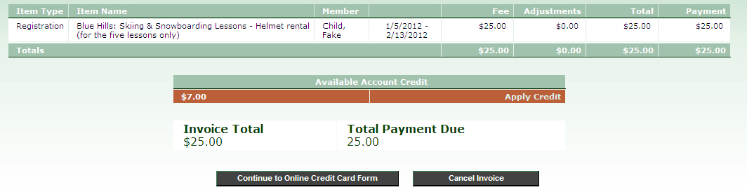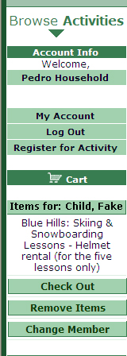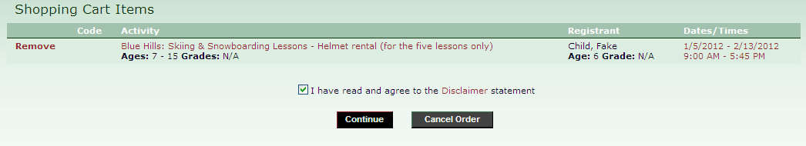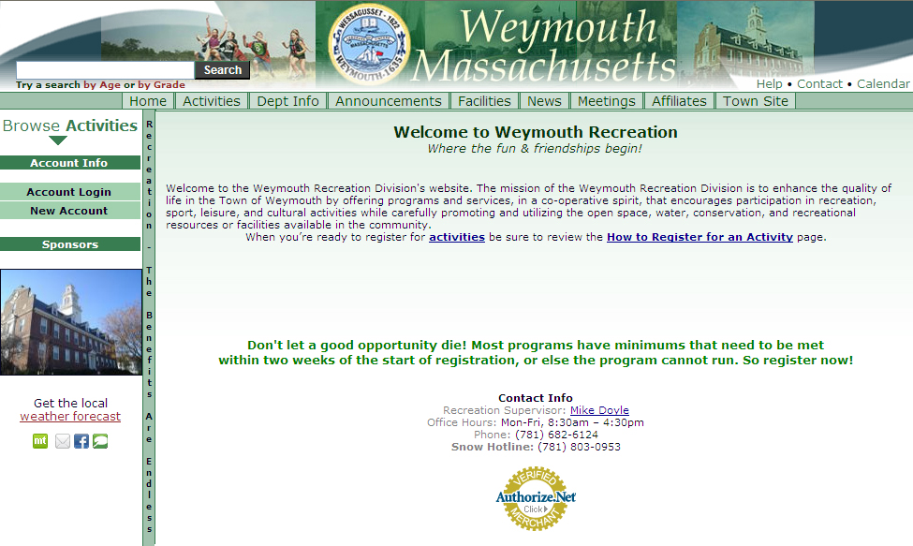

On the next screen, click **Pay Online.** An overview of your registrations will appear. If you have an Account Credit you would like to apply, choose **Apply Credit** (h). When done reviewing your registrations, choose **Continue to Online Credit Card Form** (i)**,** carefully and accurately complete the form, choose **Submit Secure Online Payment**, and – voilà - you’re done!

Once you have added all desired items to your cart, choose **Check out** (d) from the menu on the left of your screen. A new page will load. Read and agree to the **Disclaimer** (e), then choose **Continue** (f).

If you wish to remove any items from your cart, now will be the time to do so by choosing **Remove** (g) beside the items you want to remove. 

Beside the program you would like to register for, click **To Register Choose Member** (c). A new window will pop-up. Within the new window, click the name of the member you would like to register. The page will refresh, and where **To Register Choose Member** was, will now appear **Add to ____’s Cart.** Click **Add to ____’s Cart.** Your cart will appear along the left side of your screen.

First-time users should choose **New Account** (a). If you are a returning user, click **Account Login** (a). New Accounts should complete the information accordingly, returning users should sign in with their username and password. If you forget your username or password, please call our office at 781-682-6124.

Once logged in, choose **Activities** (b) from the top menu, then choose whichever activity/activities interest you, listed in red.